- 采用改良后的Lenet 激活函数使用relu 池化层使用maxpool
lr = 0.001 momentum = 0.9
Accuracy of the network on the 10000 test images: 61 %
Accuracy for class: plane is 68.4 %
Accuracy for class: car is 72.8 %
Accuracy for class: bird is 44.4 %
Accuracy for class: cat is 39.7 %
Accuracy for class: deer is 51.4 %
Accuracy for class: dog is 51.5 %
Accuracy for class: frog is 77.6 %
Accuracy for class: horse is 69.0 %
Accuracy for class: ship is 75.8 %
Accuracy for class: truck is 67.9 %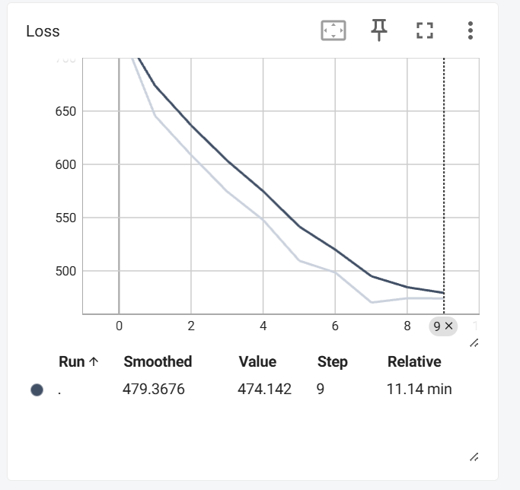

- Momentum代表动量的保留 即上一次的梯度这一次保留多少加到这一次计算出的梯度上
当momentum变小时 Loss Curve 末端结果上移 即更不宜脱离local minimum

